**PUBLIC TRANSPORT OPTIMIZATION BATCH MEMBER**

**962121104018:JOBIN E S Phase 3 submission document**

**Project Title:** Public transport optimization

**Phase 3:** Development Part 1

**Topic:** Start building the IoT-enabled public transport optimization system.

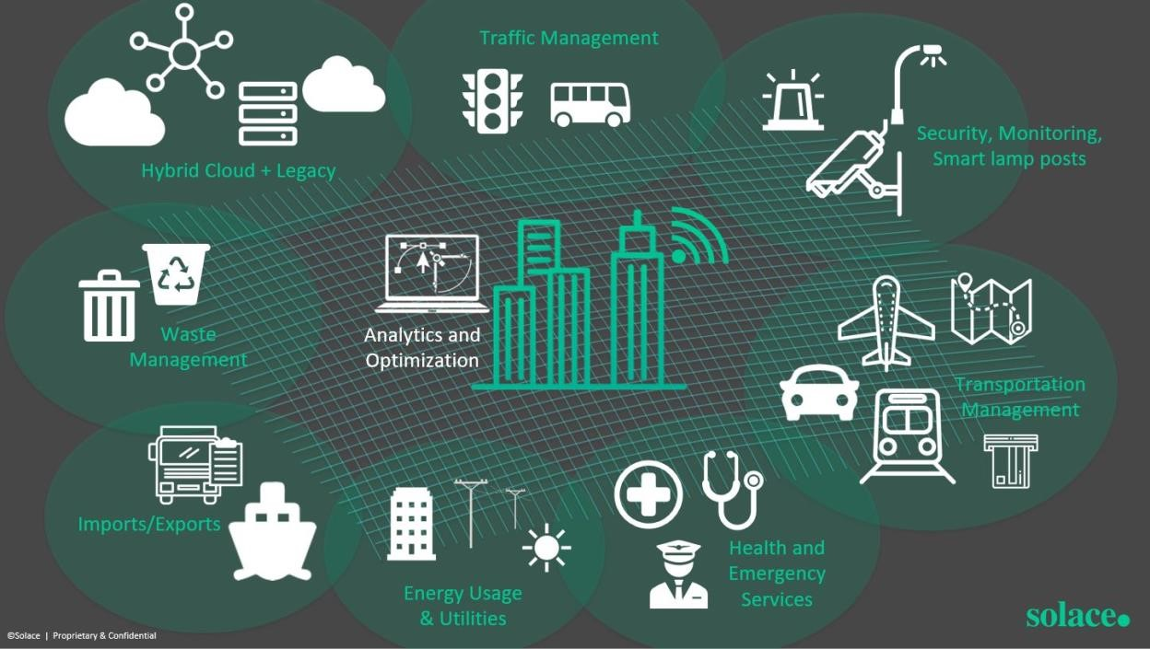

**Public transport optimization**

**Introduction:**

* Public transport optimization is a crucial facet of urban planning and transportation management.
* It involves employing strategies and technologies to enhance the efficiency, accessibility, and sustainability of public transit systems.
* By streamlining routes, improving scheduling, and implementing innovative technologies, we can create a more seamless and eco-friendly transportation experience for commuters, reducing congestion and environmental impact while enhancing overall urban mobility.
* This introduction sets the stage for exploring the multifaceted approaches to achieving an optimized public transport system.

**Given data set:**

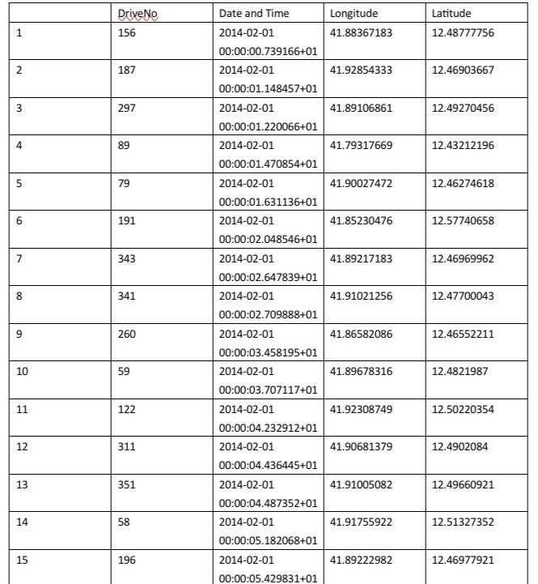

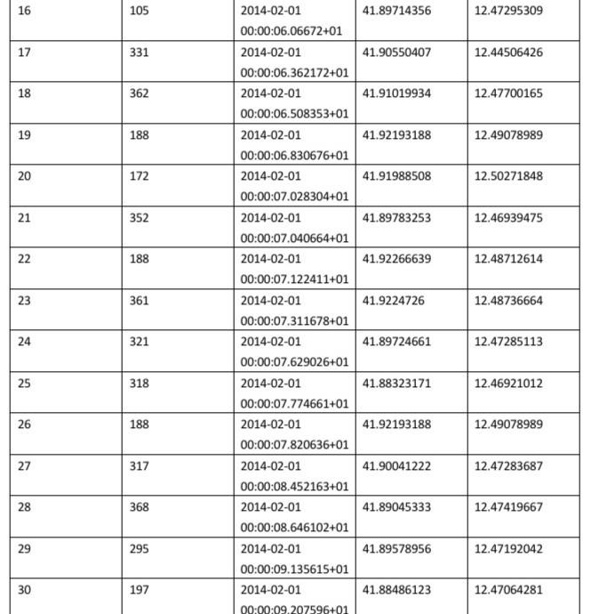

**Necessary steps to follow:**

Optimizing public transport involves several key steps:

1. **Data Collection and Analysis:**
   * Gather data on current routes, schedules, ridership patterns, and congestion points.
   * Analyze this data to identify areas for improvement.

1. **Demand Analysis:**
   * Understand the travel patterns and needs of the population.
   * Identify peak travel times and popular destinations.

1. **Route Planning and Design:**
   * Design efficient routes that connect highdemand areas.
   * Consider factors like proximity to residential areas, commercial centers, and transit hubs.

1. **Frequency and Schedule Adjustments:**
   * Adjust bus or train frequencies to meet demand.
   * Consider seasonal variations and special events.

1. **Integration with Other Modes of Transport:**
   * Ensure smooth integration with other modes like walking, cycling, or ride-sharing services.

1. **Accessibility and Inclusivity:**
   * Ensure that the system is accessible to all, including those with disabilities.
   * Consider amenities like shelters, seating, and real-time information.

1. **Technology Integration:**
   * Implement technologies like GPS tracking, automated fare collection, and real-time information systems.

1. **Environmental Considerations:**
   * Opt for eco-friendly options like electric or hybrid vehicles.
   * Promote sustainable practices in operations and maintenance.

1. **Stakeholder Engagement:**
   * Involve the community, local authorities, and transport experts in decision-making processes.

1. **Feedback Mechanism:**
   * Establish a feedback loop for passengers to provide input on their experiences.

1. **Pilot Programs and Testing:**
   * Test proposed changes on a small scale before full-scale implementation.

1. **Monitoring and Evaluation:**
   * Continuously monitor performance metrics like ridership, on-time performance, and customer satisfaction.
   * Make adjustments based on feedback and data analysis.

1. **Adaptability and Flexibility:**
   * Be prepared to adapt the system as demographics, urban planning, and technology evolve.

**Program:**

# Define function to find optimal routes Def find_optimal_routes():

# Use algorithm (e.g., Dijkstra’s, A* or other) to calculate routes

# Consider factors like demand, traffic conditions, and accessibility

# Define function to create schedules Def create_schedule():

# Use optimization algorithm (e.g., genetic algorithm, simulated annealing)

# to create schedules that minimize wait times and maximize service frequency

# Define function to monitor real-time data Def monitor_real_time_data():

# Implement a system to track vehicles in real-time

# Adjust schedules/routes based on live data

# Define function to integrate with technology

Def integrate_with_technology():

# Develop a user interface (app/website) for passengers to access information

# Define function to gather feedback Def gather_feedback():

# Establish a feedback mechanism to collect input from passengers

# Main program

If __name__ == “__main__”:

Find_optimal_routes()

Create_schedule()

Monitor_real_time_data()

Integrate_with_technology()

Gather_feedback()

**Importance of loading and processing dataset:**

**Loading and processing datasets in public transport optimization is crucial for several reasons:**

1. **Data-Driven Decision Making:**
   * Datasets provide valuable insights into current ridership patterns, travel behaviors, and congestion points. This information forms the basis for making informed decisions.

1. **Route Planning and Design:**
   * By analyzing data, planners can identify high-demand areas and design efficient routes that cater to the needs of the population.

1. **Demand Analysis:**
   * Understanding travel patterns helps in predicting peak travel times and popular destinations. This enables the optimization of schedules and frequencies.

1. **Resource Allocation:**
   * Data helps in allocating resources like vehicles, drivers, and infrastructure efficiently to meet demand.

1. **Efficiency Improvement:**
   * Data can reveal underutilized routes or services, allowing for adjustments to improve overall efficiency.

1. **Real-Time Monitoring and Adjustments:**
   * With real-time data, operators can monitor the system’s performance and make adjustments on-the-fly to respond to changing conditions.

1. **Customer Experience Enhancement:** - Analyzing data can lead to improvements in amenities, accessibility, and overall service quality, enhancing the customer experience.

1. **Safety and Security:**
   * Data analysis can help identify potential safety hazards or security concerns, allowing for proactive measures to be taken.

1. **Cost Optimization:**
   * By analyzing operational data, it’s possible to identify cost-saving opportunities, such as optimizing routes to reduce fuel consumption or adjusting schedules to minimize overtime.

1. **Environmental Considerations:**
   * Data on emissions and energy consumption can inform decisions on adopting eco-friendly technologies and practices.

1. **Regulatory Compliance:**
   * Ensuring compliance with regulations often requires detailed record-keeping and reporting, which relies on accurate and well-processed datasets.

1. **Long-Term Planning:**
   * Historical data is essential for long-term planning, allowing for predictions about future demand and infrastructure needs.

**How to overcome the challenges of loading and preprocessing the public transport optimization:**

Overcoming the challenges of loading and preprocessing public transport data involves a systematic approach and the use of appropriate tools and techniques. Here are steps you can take:

1. **Data Quality Assurance:**
   * Ensure the data is accurate, complete, and free from errors. Implement validation checks and data cleaning processes to rectify any inconsistencies.

1. **Data Standardization:**
   * Establish consistent data formats, units, and structures. This helps in integrating data from various sources.

1. **Data Integration:**
   * Merge data from different sources (e.g., GPS, ticketing systems) to create a comprehensive dataset. Use data integration tools or platforms for this purpose.

1. **Data Privacy and Security:**
   * Handle sensitive information according to privacy regulations. Implement encryption, access controls, and anonymization techniques to protect user privacy.

1. **Scalability and Performance:**
   * Use scalable technologies and distributed computing frameworks if dealing with large datasets. This ensures that the processing can handle increasing volumes of data.

1. **Automated Data Loading:**
   * Implement automated scripts or workflows to regularly load new data. This reduces manual effort and ensures that the dataset is kept up-to-date.

1. **Data Sampling and Subsetting:**
   * If dealing with extremely large datasets, consider working with smaller samples for initial analysis. This can help in identifying patterns and issues before processing the entire dataset.

1. **Data Cleaning and Transformation:**
   * Apply data cleaning techniques to remove duplicates, handle missing values, and correct errors. Transform the data into a format suitable for analysis.

1. **Feature Engineering:**
   * Extract relevant features from the data to support specific analyses or modeling efforts. This may involve aggregating or deriving new variables from existing ones.

1. **Parallel Processing and Distributed Computing:**
   * Use technologies like Apache Hadoop or Spark for distributed data processing. This allows for efficient handling of large datasets across multiple computing nodes.

1. **Use of Data Management Platforms:**
   * Employ specialized data management platforms or databases that are optimized for handling large datasets. These platforms often have built-in tools for data preprocessing.

1. **Version Control and Data Lineage:**
   * Implement version control systems to track changes to the dataset. Maintain a record of data lineage to understand how the dataset has evolved over time.

1. **Documentation and Metadata:**
   * Document the preprocessing steps and maintain metadata about the dataset. This facilitates reproducibility and helps others understand the processing steps taken.

By following these steps and leveraging appropriate technologies, you can effectively address the challenges associated with loading and preprocessing public transport data. Remember, ongoing monitoring and refinement of preprocessing techniques are essential for maintaining the quality and relevance of the dataset.

**Sensors in Internet of Things(IoT):**

Generally, sensors are used in the architecture of IOT devices.

Sensors are used for sensing things and devices etc.

A device that provides a usable output in response to a specified measurement.

The sensor attains a physical parameter and converts it into a signal suitable for processing (e.g. electrical, mechanical, optical) the characteristics of any device or material to detect the presence of a particular physical quantity.

The output of the sensor is a signal which is converted to a human-readable form like changes in characteristics, changes in resistance, capacitance, impedance, etc.

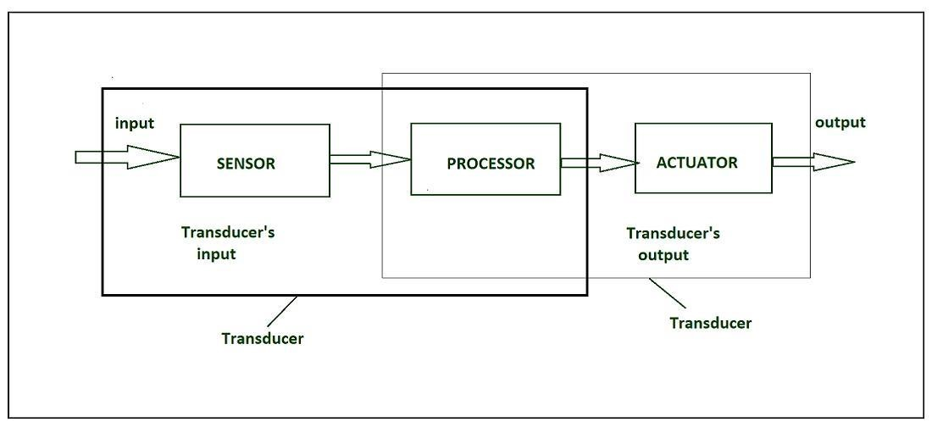

IOT HARDWARE

Transducer :

A transducer converts a signal from one physical structure to another.

It converts one type of energy into another type.

It might be used as actuator in various systems.

Sensors characteristics :

1.Static

2Dynamic

1. Static characteristics :

It is about how the output of a sensor changes in response to an input change after steady state condition.

* + Accuracy: Accuracy is the capability of measuring instruments to give a result close to the true value of the measured quantity. It measures errors. It is measured by absolute and relative errors. Express the correctness of the output compared to a higher prior system. Absolute error = Measured

value – True value

Relative error = Measured value/True value

* + Range: Gives the highest and the lowest value of the physical quantity within which the sensor can actually sense.

Beyond these values, there is no sense or no kind of response.

e.g. RTD for measurement of temperature has a range of -200`c to 800`c.

* Resolution: Resolution is an important specification for selection of sensors. The higher the resolution, better the precision. When the accretion is zero to, it is called the threshold.

Provide the smallest changes in the input that a sensor is able to sense.

* Precision: It is the capacity of a measuring instrument to give the same reading when repetitively measuring the same quantity under the same prescribed conditions.

It Implies agreement between successive readings, NOT closeness to the true value.

It is related to the variance of a set of measurements.

It is a necessary but not sufficient condition for accuracy.

* Sensitivity: Sensitivity indicates the ratio of incremental change in the response of the system with respect to incremental change in input parameters. It can be found from the slope of the output characteristics curve of a sensor. It is the smallest amount of difference in quantity that will change the instrument’s reading.
* Linearity: The deviation of the sensor value curve from a particularly straight line. Linearity is determined by the calibration curve. The static calibration curve plots the output amplitude versus the input amplitude under static conditions.

A curve’s slope resemblance to a straight line describes linearity.

* Drift: The difference in the measurement of the sensor from a specific reading when kept at that value for a long period of time.
* Repeatability: The deviation between measurements in a sequence under the same conditions. The measurements have to be made under a short enough time duration so as not to allow significant long-term drift.

**Dynamic Characteristics :**

Properties of the systems

* Zero-order system: The output shows a response to the input signal with no delay. It does not include energy-storing elements.

Ex. Potentiometer measure, linear and rotary displacements.

* First-order system: When the output approaches its final value gradually. Consists of an energy storage and dissipation element.
* Second-order system: Complex output response. The output response of the sensor oscillates before steady state. **Sensor Classification :**
* Passive & Active
* Analog & digital
* Scalar & vector

1.Passive Sensor –

Can not independently sense the input. Ex- Accelerometer, soil moisture, water level and temperature sensors.

2.Active Sensor –

Independently sense the input. Example- Radar, sounder and laser altimeter sensors. 3.Analog Sensor –

The response or output of the sensor is some continuous function of its input parameter. Ex- Temperature sensor, LDR, analog pressure sensor and analog hall effect.

4.Digital sensor –

Response in binary nature. Design to overcome the disadvantages of analog sensors. Along with the analog sensor, it also comprises extra electronics for bit conversion. Example – Passive infrared (PIR) sensor and digital temperature sensor(DS1620).

5.Scalar sensor –

Detects the input parameter only based on its magnitude. The answer for the sensor is a function of magnitude of some input parameter. Not affected by the direction of input parameters.

Example – temperature, gas, strain, color and smoke sensor. 6.Vector sensor –

The response of the sensor depends on the magnitude of the direction and orientation of input parameter. Example – Accelerometer, gyroscope, magnetic field and motion detector sensors.

**Types of sensors –** • Electrical sensor :

Electrical proximity sensors may be contact or non contact.

Simple contact sensors operate by making the sensor and the component complete an electrical circuit.

Non- contact electrical proximity sensors rely on the electrical principles of either induction for detecting metals or capacitance for detecting non metals as well.

* Light sensor:

Light sensor is also known as photo sensors and one of the important sensor.

Light dependent resistor or LDR is a simple light sensor available today.

The property of LDR is that its resistance is inversely proportional to the intensity of the ambient light i.e when the intensity of light increases, it’s resistance decreases and vise versa.

* Touch sensor:

Detection of something like a touch of finger or a stylus is known as touch sensor.

It’s name suggests that detection of something.

They are classified into two types:

1.Resistive type

2.Capacitive type

Today almost all modern touch sensors are of capacitive types.

Because they are more accurate and have better signal to noise ratio.

* Range sensing:

Range sensing concerns detecting how near or far a component is from the sensing position, although they can also be used as proximity sensors.

Distance or range sensors use noncontact analog techniques. Short range sensing, between a few millimetres and a few hundred millimetres is carried out using electrical capacitance, inductance and magnetic technique.

Longer range sensing is carried out using transmitted energy waves of various types eg radio waves, sound waves and lasers.

* Mechanical sensor:

Any suitable mechanical / electrical switch may be adopted but because a certain amount of force is required to operate a mechanical switch it is common to use micro-switches.

* Pneumatic sensor:

These proximity sensors operate by breaking or disturbing an air flow.

The pneumatic proximity sensor is an example of a contact type sensor. These cannot be used where light components may be blown away.

* Optical sensor:

In there simplest form, optical proximity sensors operate by breaking a light beam which falls onto a light sensitive device such as a photocell. These are examples of non contact sensors. Care must be exercised with the lighting environment of these sensors for example optical sensors can be blinded by flashes from arc welding processes, airborne dust and smoke clouds may impede light transmission etc.

* Speed Sensor:

Sensor used for detecting the speed of any object or vehicle which is in motion is known as speed sensor .For example – Wind Speed Sensors, Speedometer ,UDAR ,Ground Speed Radar .

* Temperature Sensor:

Devices which monitors and tracks the temperature and gives temperature’s measurement as an electrical signal are termed as temperature sensors .These electrical signals will be in the form of

voltage and is directly proportional to the temperature measurement

**Program:**

import requests import time from gps_module import get_location_data # Implement the function to get GPS data

from ridership_module import get_ridership_data # Implement the function to get ridership data

API_URL =

"https://transit_information_platform.co m/api/endpoint"

API_KEY = "your_api_key_here"

def send_data(location, ridership):

payload = {

"location": location,

"ridership": ridership

}

headers = {

"Authorization": f"Bearer {API_KEY}" }

response = requests.post(API_URL, json=payload, headers=headers)

if response.status_code == 200: print("Data sent successfully!") else:

print(f"Error sending data. Status code: {response.status_code}")

def main(): while True:

location = get_location_data() # Implement this function to get real-time location

ridership = get_ridership_data() # Implement this function to get real-time ridership data send_data(location, ridership)

time.sleep(30) # Adjust this interval based on your requirements

if __name__ == "__main__":

main()

**Conclusion:**

* In conclusion, optimizing public transport is imperative for creating sustainable, efficient, and accessible urban environments.
* Through measures like improved route planning, enhanced technology integration, and prioritizing ecofriendly modes, cities can alleviate congestion, reduce emissions, and enhance the overall quality of life for their residents.
* Furthermore, public engagement and collaboration between stakeholders are essential for successful implementation.
* Investing in public transport optimization is a pivotal step towards building smarter, more livable cities for generations to come.